Power Platform + AI: Get Future-Ready & Accelerate Innovation.

# **Business Use Case: IT Help Desk Solution**

In this workshop, we’ll develop an AI-powered Help Desk Service solution designed to streamline IT support, automate ticket routing/troubleshooting, and enhance user experiences through predictive insights and intelligent automation. This solution will incorporate Power Apps for user interactions, AI Builder for automating ticket classification & routing, Copilot Studio for creating a sophisticated AI-driven support assistant, Azure OpenAI for natural language processing and AI Search powered custom connector for quick information retrieval.

**Lab 1: Building the IT Help Desk App with Power Apps (45 mins)**

* **Objective:** Create a Power App that serves as the user interface for submitting and tracking IT support requests.
* **Tasks:** 
  + Design a simple interface for users to submit and track IT support tickets using the maker copilot.
  + Implement a form for capturing ticket details (issue description, priority, type etc.).
  + Screen to display ticket status and history for both users and IT staff.
* **Outcome:** You will have a functional IT Help Desk app that facilitates the submission and management of IT support requests.

# Create the Application with Copilot

1. Go to make.powerapps.com and confirm that you are in your environment.

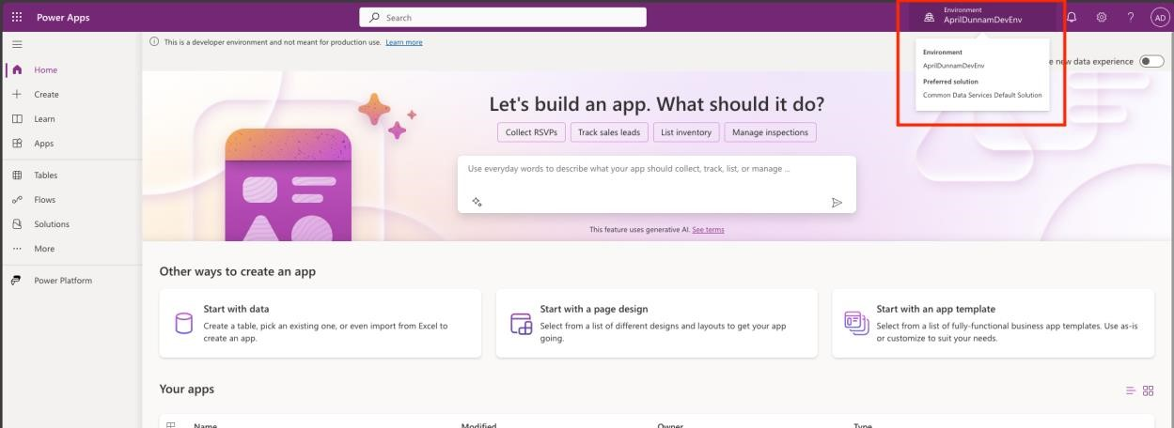

1. In the Copilot text box, paste the following prompt:

Create an app to manage IT support tickets. It must allow employees to create a ticket with the issue description, priority, type (software, hardware, etc), submitter, assigned to and status (pending, assigned, resolved, etc)

Press ENTER

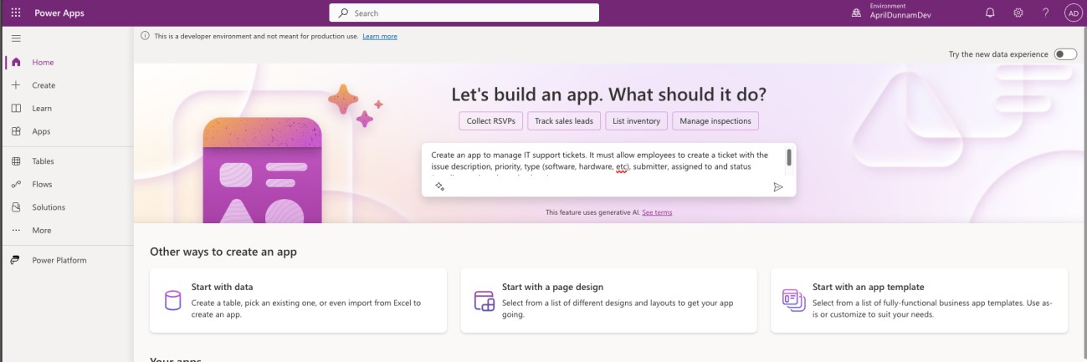

1. Review the table structure Copilot created for you. Please note that given the nature of Copilot, the results can and will vary in what it creates for you so you might have to tweak further with Copilot to get exactly what you want. Ensure that you have the following columns in your table:

|  |  |  |
| --- | --- | --- |
| **Name** | **Column Type** | **Values** |
| Ticket ID | Single Line of Text |  |
| Issue Description | Single Line of Text |  |
| Priority | Choice | Low, Medium, High |
| Type | Choice | Software, Hardware, Network |
| Submitter | Single Line of Text |  |
| Assigned To | Single Line of Text |  |
| Status | Choice | Pending, Assigned, Resolved |

1. If any of the columns don’t match what is listed above, use the Copilot panel on the right-hand side and put in prompts to change the column names, values or add new columns. For example, “add a choice column for status”, etc. You can also ask Copilot to “add 10 more rows of data” so that you have more sample data for your app.
2. When you are finished designing your table structure, select “Create App” in the bottom right-hand corner. This will create the Dataverse table and a responsive canvas app for you to use. *Note: This can take a couple of minutes to create.*

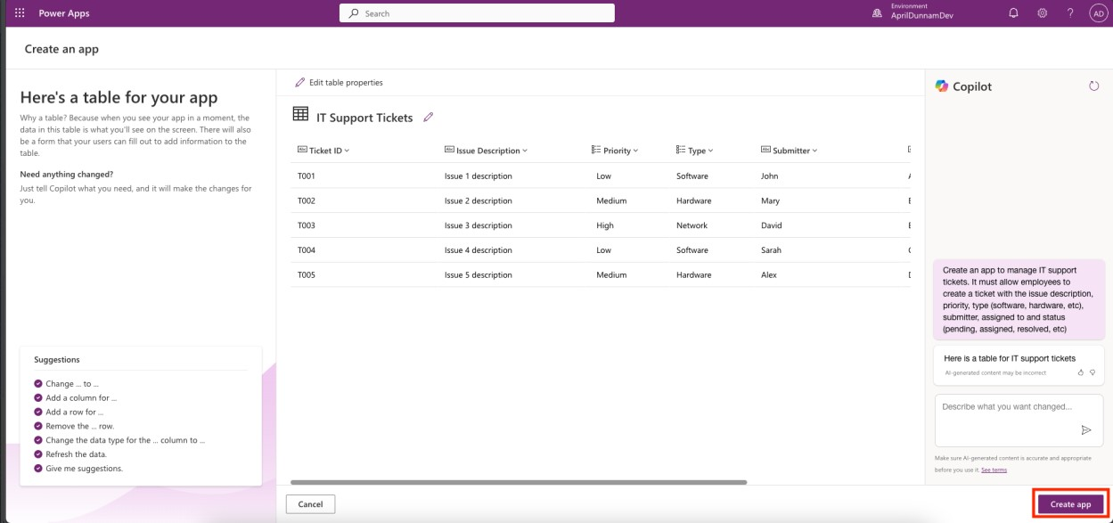

1. Once your app loads, press **SKIP** in the popup window and explore your new app.

Test that you can search for items in the gallery. Click on different items and make

sure you can see the data for a selected item. Also test that you can add a new item.

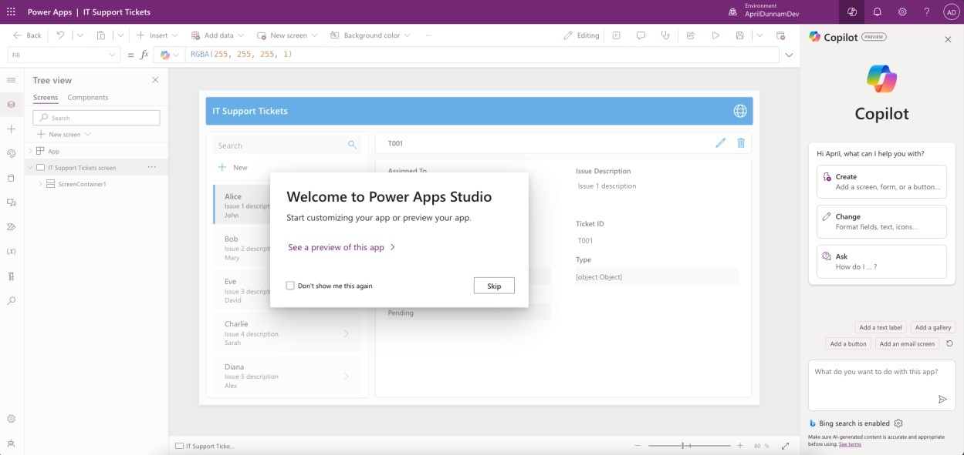

1. Select the RecordsGallery 1 object and select the **FIELDS** option in the toolbar

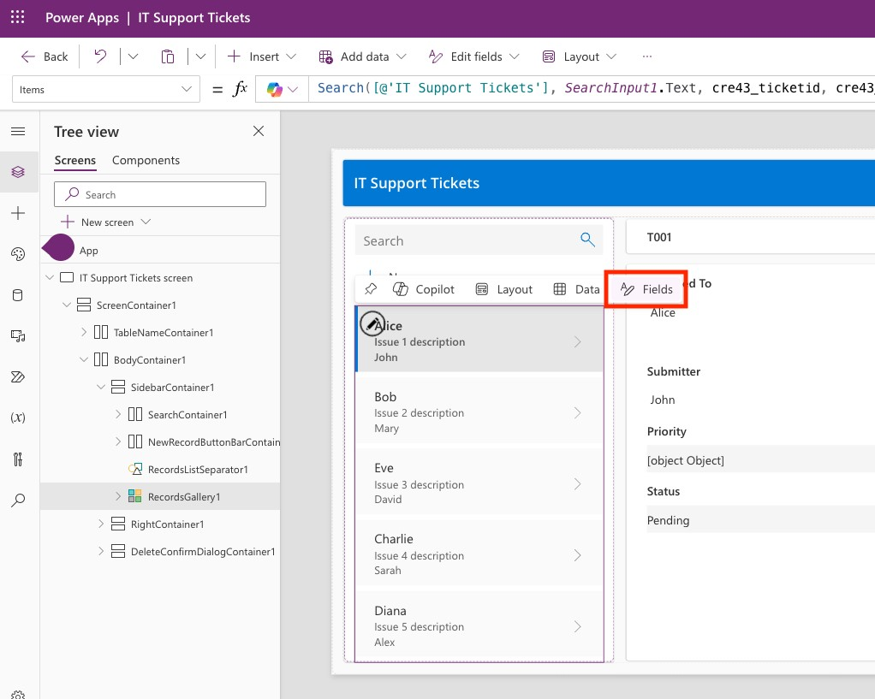

1. Ensure that your Title, Subtitle1 and Body 1 properties are configured as shown below:

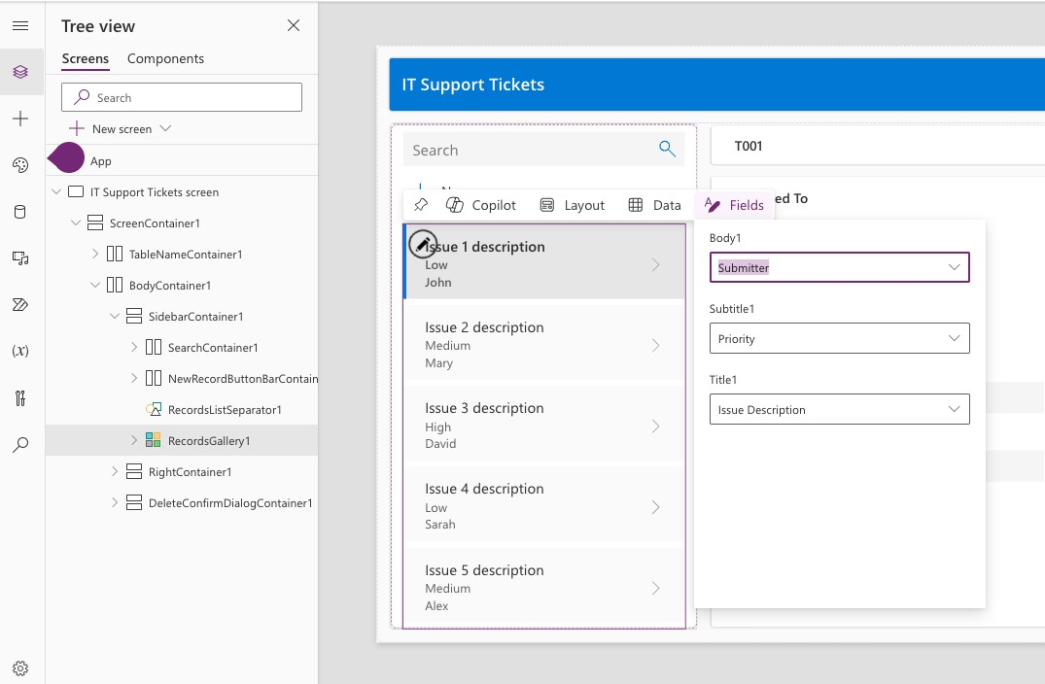

# Using Copilot to Format by Example

1. Now we’ll use Copilot to help us write Power Fx by describing what we want. Select the Body1 object in the RecordsGallery1 which should be mapped to the Submitter column from the previous step. When you select the object a toolbar will appear above, select the **COPILOT** button and choose the **TEXT FORMATTING** option.

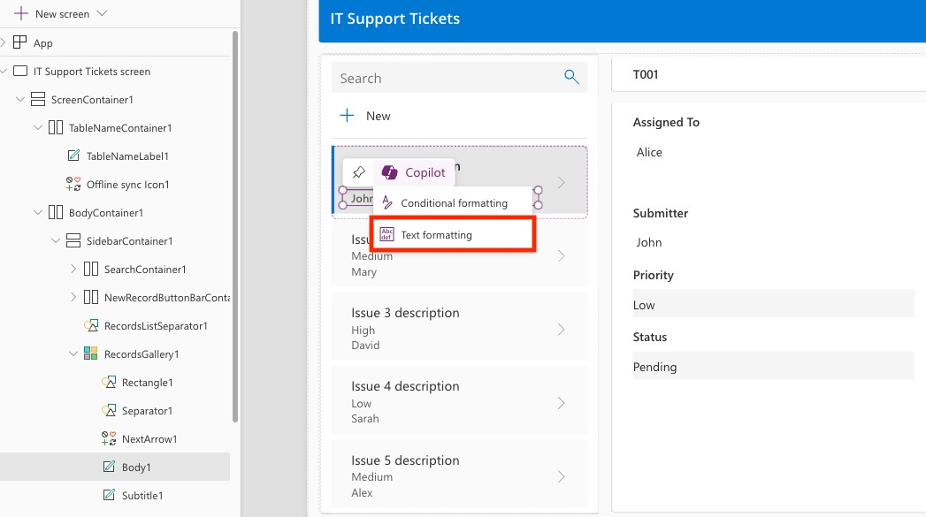

1. A window will pop up on the right-hand side of the screen with a text box for you to put in the desired format for the data. In this text box enter in the following text, replacing the Submitter name with whatever is showing in the “Current Format” for you (see screenshot for reference) and press ENTER:

Submitted By: John

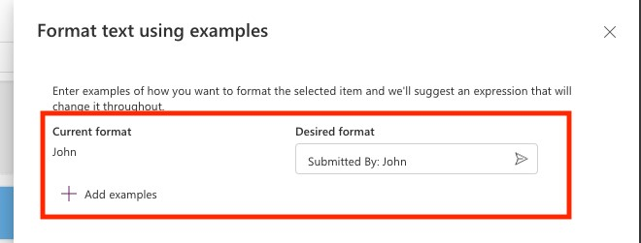

1. This will provide you with a suggested formula to format the text as shown below.

Click on the formula suggestion and select the **APPLY** button at the bottom to apply

this formula to the object in the gallery.

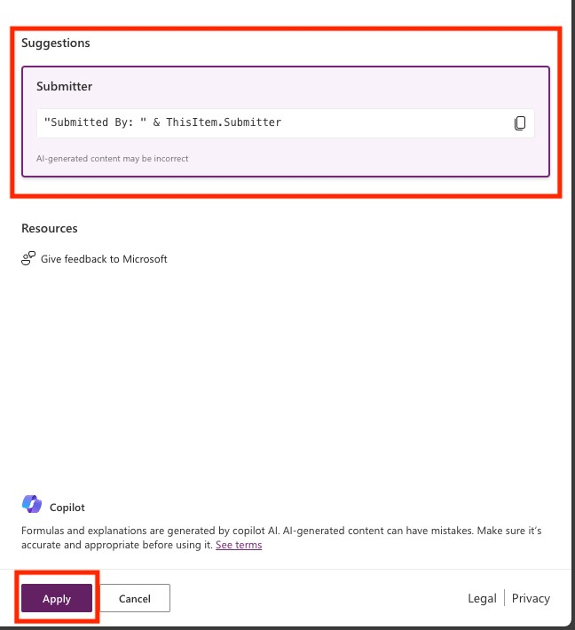

1. Verify that your gallery looks like below with the submitter information formatted

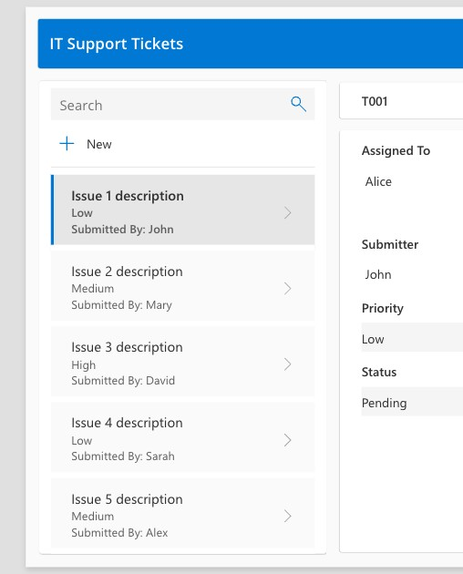

# Use Copilot to write Power Fx

1. Now we want to format the priority object in the gallery so that it’s color coded. Select the **Subtitle1** object in the **RecordsGallery1** which should be mapped to the

Priority column. Select the **COLOR** property from the Properties dropdown in the

upper left-hand side of the screen

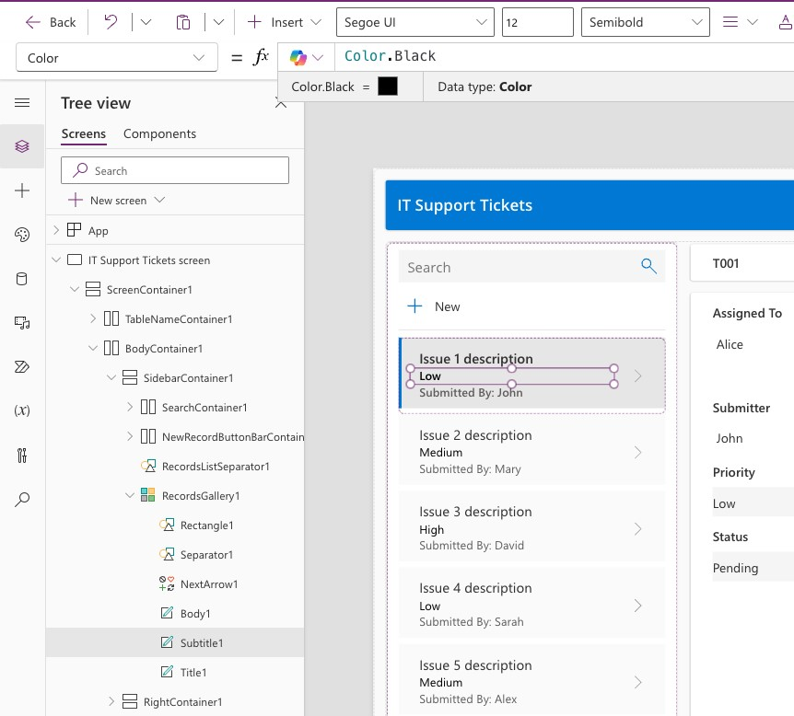

1. We will use Copilot for Power Fx to have it suggest a formula for color coding. Erase what is in the color property and copy the following prompt in the text box and press the space bar. You will see text pop up that says “Generating” wait for that to complete and it will suggest a formula in gray. Press **TAB** to accept the formula and verify that your object is color coded. *Note: To have Copilot write Power Fx you put in your prompt as a comment using //*

//If "Low", green, "Medium", yellow, "High", red

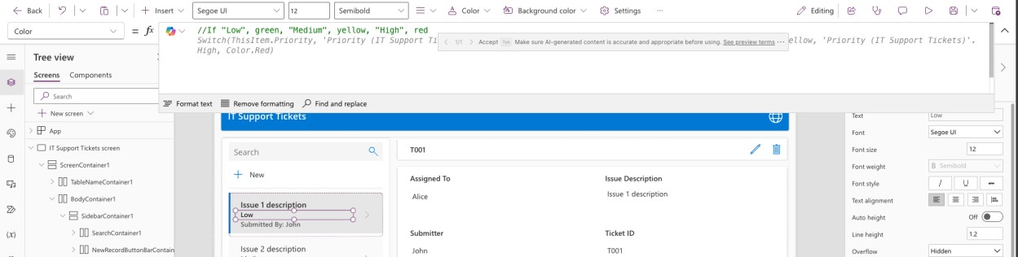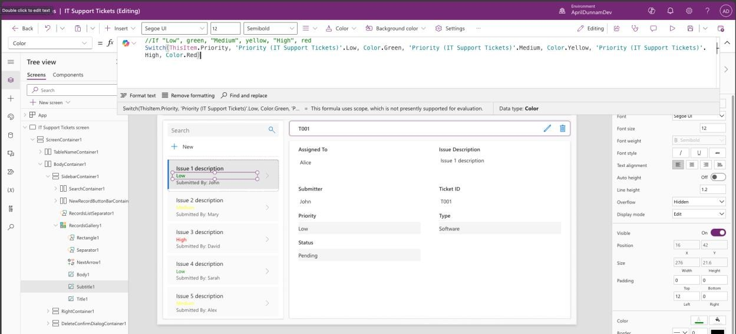

# Use the maker Copilot to create app objects

1. Now we’ll use the Maker Copilot to add a new screen to our application for help desk staff to see a tabular view of all the help desk tickets. To open the Maker Copilot, select the Copilot icon in the upper right-hand corner of the screen

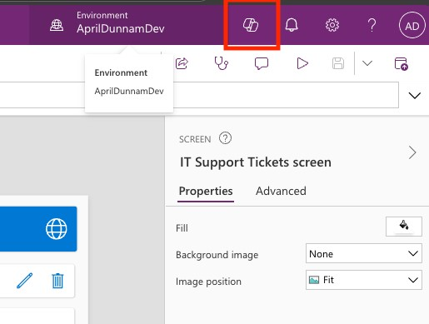

1. Now type the following prompt in the text input and press **ENTER**

Add a new Header and Table screen titled Dashboard

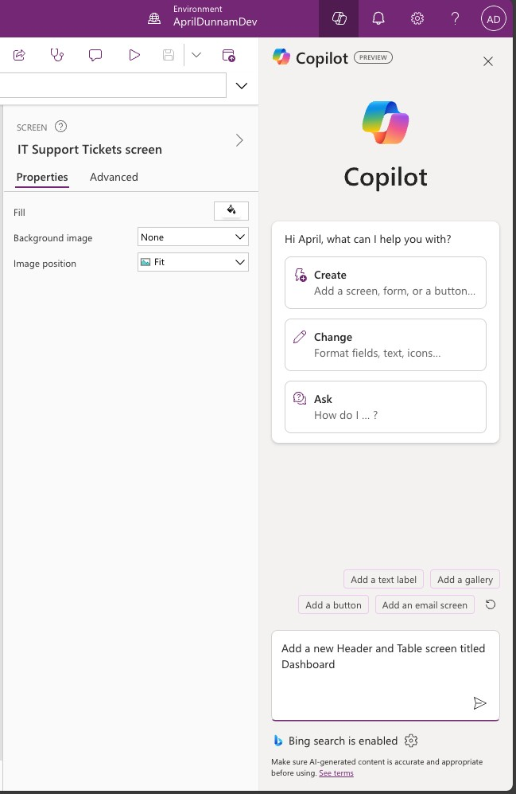

1. This should add a new screen for you.

# Optional Steps if Copilot does not create the new screen for you

1. If you cannot get Copilot to create the new screen for you, you can follow these steps to create it manually
2. Select the NEW SCREEN button on the left-hand side of the screen in the tree view. 20. Scroll down the list of screen templates and select the Header and Table template.

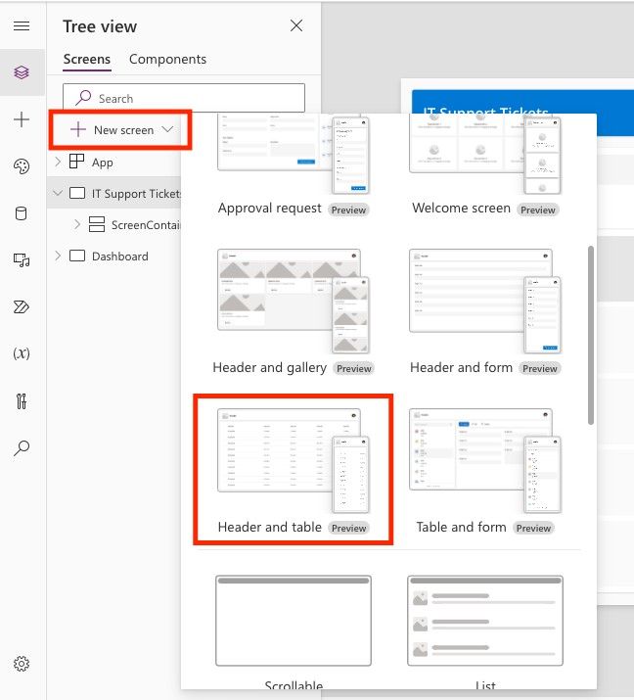

1. Navigate to the new screen it created and select the Table1 object. When the

“Select a data source” pop up opens, select your data table from the list to map it

to the **IT Tickets** data source.

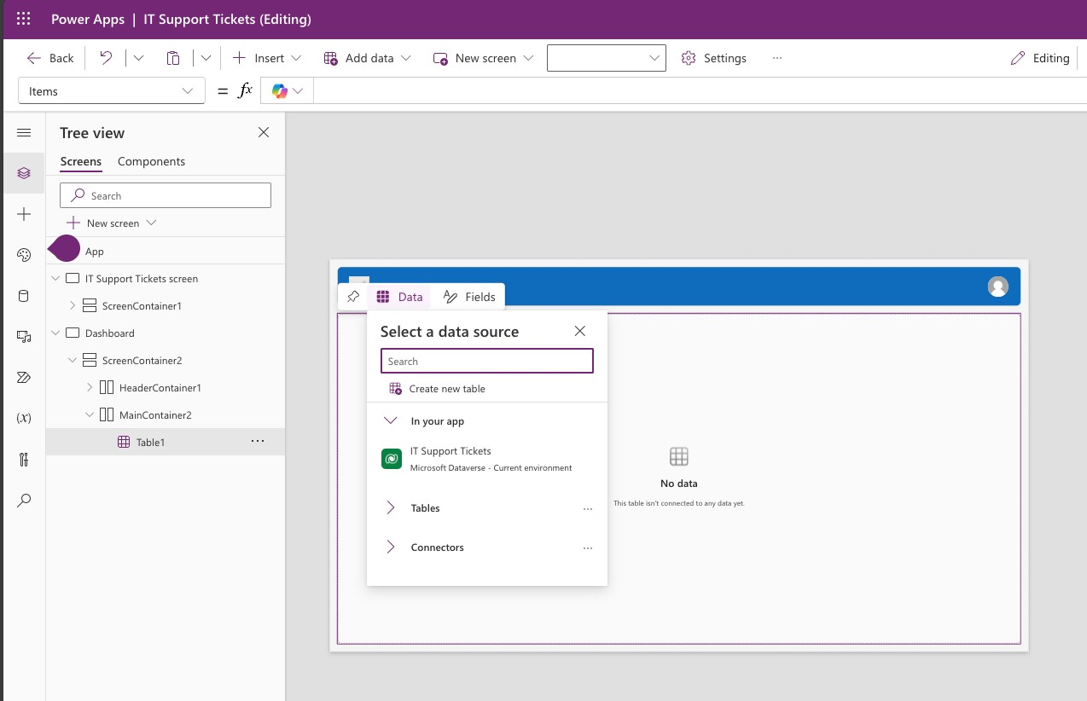

1. Review the data source and note that behind the scenes, Copilot is suggesting what columns it feels are most relevant to show in the table.

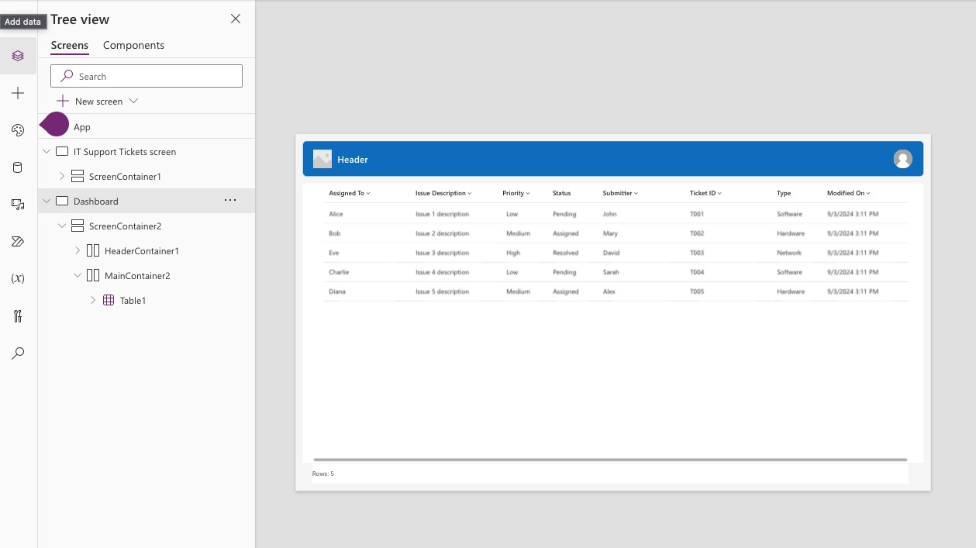

1. Once you have verified that the app works, click the **PUBLISH** button in the upper right-hand corner.

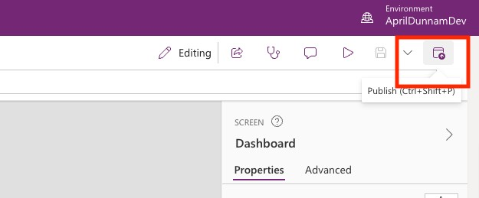

1. A menu will display asking you to confirm your app name and description. Select **PUBLISH THIS VERSION** and your app will be ready!

